# Demo Script

Slides:https://docs.google.com/presentation/d/1-WhKUuG6X8JUipsgAFmju4WXDbCziyFpmtuyxjHXFzQ/edit?usp=sharing

-- Preparations --

* Make sure the screen recording is ready
* Make sure the code to be shown for Use Cases is organized, ready to display
* Have powerpoint ready
* Connect to projector

## 1. Show the short movie to give the audience a context / role play

-- Role play manuscript --

* Storyteller: The person who will read the scene out loud, describe what the actors are doing
* Lead actor: The person who will portray a potential user. Remains quiet until the end.
* Roommate: The person who will give directions through gesture. Remains quiet.

*All participants are in the front of the classroom*

*Storyteller*: “It is Sunday afternoon and “Lead actor” is feeling like going on an adventure. The afternoon rains have just finished and the temperature outside is perfect for a lovely walk in the nature. So “Lead actor” would like to go to the Botanic Gardens, asks his/her roomate for directions and hops on the bus.”

*Lead actor asks roommate for directions.*

*Roommate waves and points.*

*Lead actor walks a few steps across the stage and imitates stepping onto a bus.*

*Storyteller:* “Lead actor” remembers the name of the bus stop and knows that it will be 8 stops before its time to get off. But his/her mind starts to wonder, he/she starts thinking about the Software Engineering project due next week.”

*Lead actor looks dreamily into to the air.*

All of a sudden “Lead actor” realizes that he/she has been zoning out for a long time. He/she checks on a map and realizes that he/she must have passed Botanic Gardens.

*Lead actor “sits up” with a start.*

Lead actor: “Don’t you just hate it when you are going somewhere new, but don’t know how to get there? Perhaps you’ve learned how to use Google Maps or something similar, and you begin your journey. Now if you’re a somewhat nervous traveller or not used to technology, you may end up sitting and staring at your phone to see how you are moving along the map and getting closer to your destination. You’re missing all the fun! You don’t have time to look at your surroundings, getting to know the city or connecting with the people around you. Or you might be daydreaming, like me, and not realize when it’s time to get off! What to do?”

*End of role play.*

## 2. Mission and overview of your use case diagram to explain main functionalities of your product and who are the expected users

**-- Introduction --**

Don’t you just hate it when you are going somewhere new, but don’t know how to get there? Perhaps you’ve learned how to use Google Maps or something similar, and you begin your journey. Now if you’re a somewhat nervous traveller or not used to technology, you may end up sitting and staring at your phone to see how you are moving along the map and getting closer to your destination. You’re missing all the fun! You don’t have time to look at your surroundings, getting to know the city or connecting with the people around you. Or you might be daydreaming, like me, and not realize when it’s time to get off! What to do?”

We are here to help you keep calm and Get Going!

**-- Mission --**

We have designed an Android application called Get Going that will ease your day to day travels.

**How?**

We will do this by having the user submit their travel details, giving them the possibility to follow their journey in real time on a map and sending them an alert when they are approaching the destination.

**Who will be interested?**

Our main target groups are people who have difficulties navigating where they are and who require assistance in their travels - senior citizens and people who are travelling to places they’ve never been before. Our application will help them get where they want to go, and let them relax while doing so.

-- Overview of use case diagram —

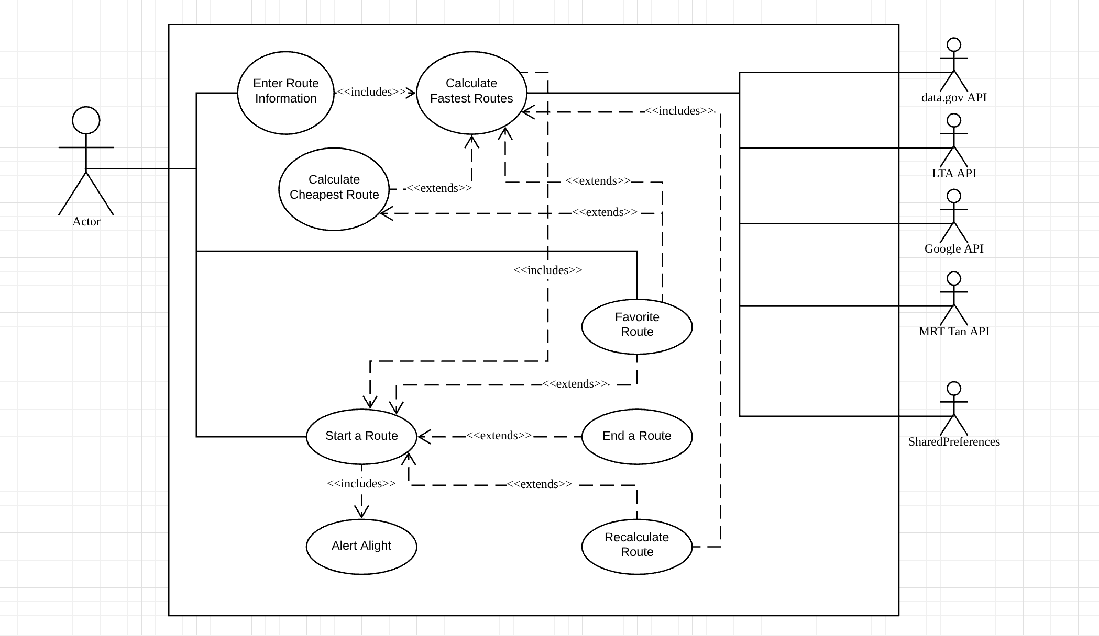

The user will begin by entering information into the application, upon which the application calls Google Maps API to retrieve possible routes, and the data.Gov API, MRT Tan API and LTA API to retrieve information about the fares. The user can choose to sort the routes by time duration or by price. The user can then choose to start a route.

Once the journey is coming to its end, the user will be alerted. If the user misses the stop, he or she will be directed back to search page with new suggestions of how to reach end destination. If the user did get off at the desired stop, he or she can confirm that the destination is reached.

When the journey is completed the user can find it in a history of journeys made and from there choose a favorite route.

## 3. Show the screen recording of the application

Steps in showing the app:

1. **Start the app**
2. **Click on History**, pause for: “Before the user has used the app, this page will not have any past routes to display. It will encourage the user to start a route.”
3. **Click on Favorites**, pause for: “If the user does not have any favorite routes, this page will look like this”.
4. **Click on Search**
5. **Check box**, pause for: “The user can choose which transportation mode will be included in the route - bus or MRT”.
6. **Enter origin**, pause for: “The user can enter origin in the form of ___.”
7. **Enter destination**, pause for: “The user can enter destination in the form of ___.
8. **Choose time,** pause for: “The user can choose to plan by departure or arrival time”.
9. **Set time**, pause for: “The user chooses at what time they want to travel”
10. **Set date**, pause for: “The user can choose which date to travel”
11. **Click on Create Route,** pause for: “And clicks on Route”.
12. **Pause**, “Here we can see all the possible routes. They are sorted by shortest time duration by default. By clicking on the two sort buttons, the routes can be sorted by time or price.
13. -- Steps in the map activity -- Please add!

-- Activity has ended

1. **Click on History,** pause for: “Once the user has finished the route, they can see the route here.”
2. **Click on Star**, pause for: “If the user wants, they can add a route to favorites”
3. **Click on Favorite in navigation**, pause for: “We can now see the route we just added. From here we can select a route that we want to travel again”.
4. **Click on Arrow**
5. **Viewing Search**, pause for: “Here we can see that the favorited information is already enter into the form. We include only mode of transport, origin and destination as it is highly likely that the user will be traveling at a new time compared to the saved route.”
6. **Click on Favorite in navigation**, pause for: “The user can delete a favorite by clicking on the star.”
7. **Click on Star,** pause for: “Now the favorite has disappeared”
8. **Click on History**, pause for: “The route remains in the history view. And it is no longer starred.”

## 4. You should discuss good SE practices you applied in the course of your project, an overview of your system design, and how these good practices and designs allow you to easily support envisioned further upgrades.

We ensured our code is reusable for possible future upgrades. For example, we hope to include a future route planning algorithm in our software. Reusing the code we have for “current” route planning, we need to further extend this feature to be useful for future route planning; the current code allows us to extract all routes for departure time at current time. By further utilizing this, we can allow users to be suggested routes starting at various other departure time or ending at various other arrival time by simply modifying the url request to Google Maps API. Hence, we don’t need to reuse the display Route and display polyline functions as such. We have ensured that we have packaged the existing functionality into something reusable by multiple projects without copying and pasting the code.

## 

We have also ensured out classes is simple and easy to understand, with each class having only one or two responsibilities. For example, activity_fav page is responsible for displaying the filled up or empty favorite page and the navigation across the navigation bar. The control_activity_fav is responsible for most of the logic that the activity_fav needs; such functionalities include accessing the saved routes from Shared Preferences and unfavoriting a route from the saved Routes in Shared Preferences.

## 

## 5. You should also demonstrate the good traceability in your project deliverables. You may choose one or two specific use cases, and present the relevant class diagrams and sequence diagrams for the chosen use case, mention good designs you applied, how you implemented them, what testing you performed. This may take **2-3 minutes**. You may consider demonstrating traceability from within modeling tools and IDEs.

Use case 1: Add favorite route

Use case 2: Delete favourite route

|  |  |  |  |
| --- | --- | --- | --- |
| Use Case ID: | ROUTE-4 | | |
| Use Case Name: | Add favorite route | | |
| Created By: | Surabhi | Last Updated By: | Isabel |
| Date Created: | 2019-03-10 | Date Last Updated: | 2019-03-12 |

|  |  |
| --- | --- |
| Actor: | User (initiating) & System |
| Description: | Allows the user to save routes as favorites for future use |
| Preconditions: | This use case extends ROUTE-2 and ROUTE-3. It is initiated when the user clicks on symbol next to route.  The user must have entered route information that has been verified. |
| Postconditions: | Route is added to Favourite list |
| Priority: | Low |
| Frequency of Use: | Once a month |
| Flow of Events: | 1. The system saves the origin, destination, mode of transport and specific calculated route to database 2. System displays a message or indication to the user to inform that the route has been added to favorites 3. The favorited route is now viewable in “Favorites” |
| Alternative Flows: |  |
| Exceptions: |  |
| Includes: |  |
| Special Requirements: | System response time must not exceed 1 minute |
| Assumptions: |  |
| Notes and Issues: |  |

|  |  |  |  |
| --- | --- | --- | --- |
| Use Case ID: | ROUTE-5 | | |
| Use Case Name: | Delete favorite route | | |
| Created By: | Surabhi | Last Updated By: | Isabel |
| Date Created: | 2019-03-10 | Date Last Updated: | 2019-03-12 |

|  |  |
| --- | --- |
| Actor: | User |
| Description: | Allowing the user to delete routes from Favorites |
| Preconditions: | This use case extends ROUTE-4.  The user must have at least one favorite route saved. |
| Postconditions: | Route is deleted from Favorites |
| Priority: | Low |
| Frequency of Use: | Once a month |
| Flow of Events: | 1. The user views favorited routes 2. The system shows a list of routes the user has favorited sorted by time 3. The user selects a route to be deleted 4. System displays a message “Route deleted from favourites” |
| Alternative Flows: |  |
| Exceptions: |  |
| Includes: |  |
| Special Requirements: |  |
| Assumptions: |  |
| Notes and Issues: | Users cannot delete a route from History. |

-- Class diagram --

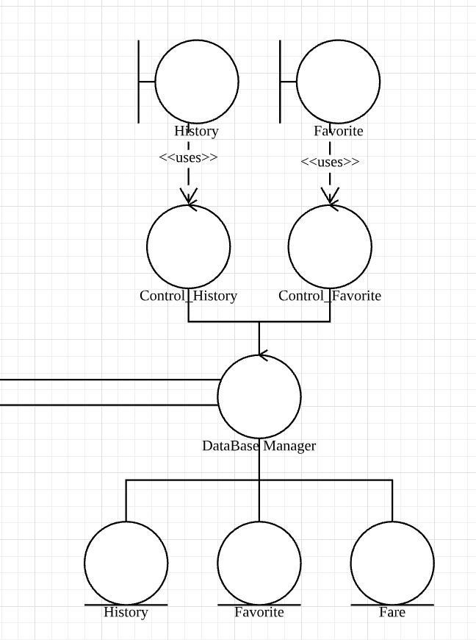

-- Sequence diagram --

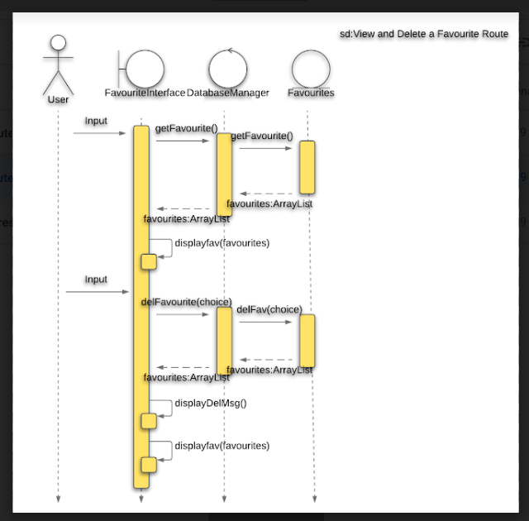

-- Show code --

Pictures in slide